PROCEEDS TO ST. MARY’S CHURCH, SWEFFLING

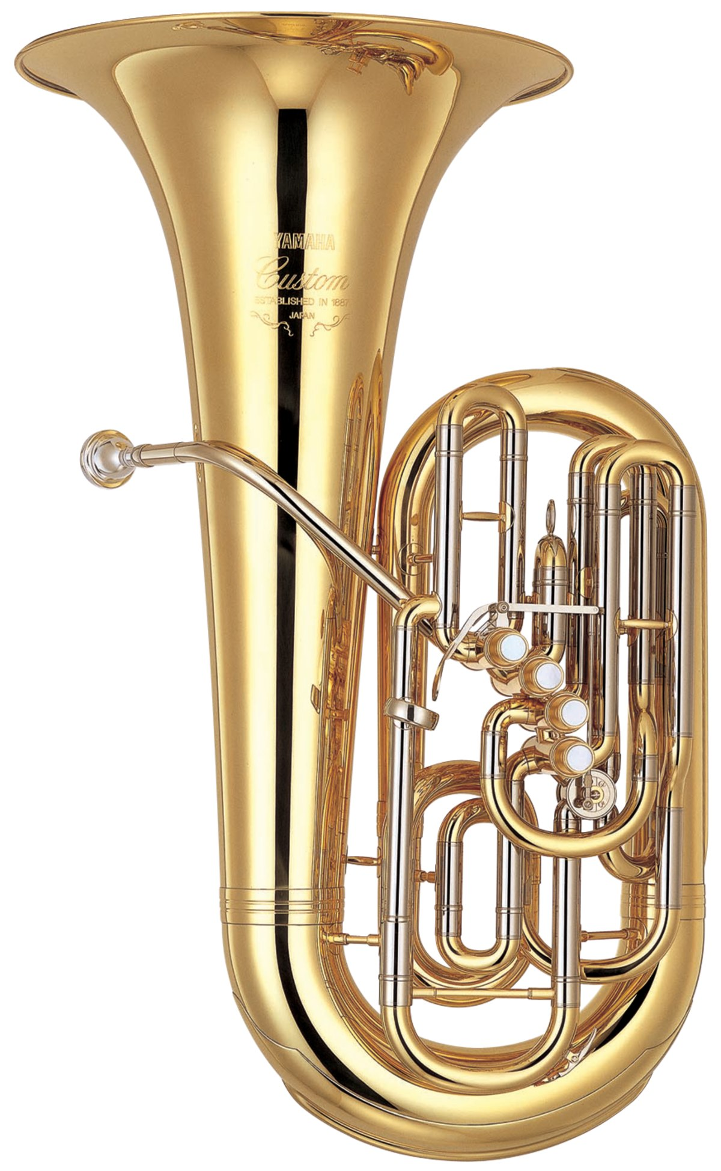

[This Photo](https://en.wikipedia.org/wiki/Tuba) by Unknown Author is licensed under [CC BY-SA](https://creativecommons.org/licenses/by-sa/3.0/)

CHRISTMAS

BRASS

CONCERT

LEISTON ROYAL BRITISH LEGION BRASS BAND

FRIDAY DECEMBER 9th

7.30 p.m. SWEFFLING CHURCH

TICKETS £8.00 ADULTS,

£4.00 CHILDREN UNDER 16

FROM DIANA(01728 663578)

or SHEILA (01728 663518)