**CHRISTMAS**

**BRUNCH**

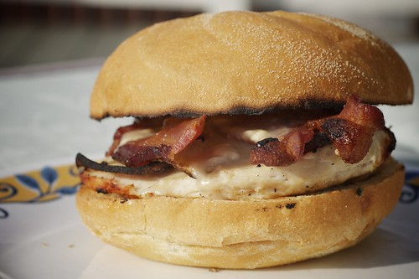

[This Photo](https://www.flickr.com/photos/kylewith/7245196358/) by Unknown Author is licensed under [CC BY-SA-NC](https://creativecommons.org/licenses/by-nc-sa/3.0/)

**& MARKET**

**SWEFFLING HUT**

**SATURDAY DECEMBER 3RD**

**10.00 a.m. – 12.00 noon**

**BACON AND EGG ROLLS**

**FRESHLY BREWED TEA/COFFEE**

**CHRISTMAS THEMED STALLS**

**RAFFLE FREE ENTRY**

**PROCEEDS TO ST. MARY’S CHURCH**