**The Rev. Martin Percival 01728 598455**

**e-mail: revmepercival@gmail.com**

**THE BRIDGE**

**Church and Village magazine for Sweffling**

**April/May2023**

**An Easter message from the Rev. Percival:**

Recently someone said to me that we can face anything, endure anything, as long as we know or believe that it

will not last forever and that something better will turn

up. For example, people will face a long, painful and dangerous operation if they believe that it will make

them well again. Prisoners can face long sentences as

long as they believe that it will end and that they will

enjoy freedom again. We can face the rigours of a long

and miserable winter because we know that the spring

will come again.

What all this underlines is the importance of hope. Hope is as necessary for the spirit as bread is for the body. It is amazing what the human spirit can endure provided it is

nourished by the bread of hope.

Easter provides and enormous injection of hope for the human spirit. If we are honest

we have to agree that it is much needed. There is a lot of tragedy in life. Good things are destroyed. Good people are cut down.

Our Lord was cut down much to the surprise and horror of his followers. However, as

we know, that was not the end of the story. On reflection, however, the world did not

take much notice of the resurrection of Jesus. The reason for this lies in the fact that it

was a humble, hidden event. He did not appear in triumph in the Temple of Jerusalem, humiliating those who humiliated him. Only those who he called by name, with whom

he broke bread and to whom he spoke words of peace, were aware of what happened.

Even they had difficulty in believing. Like us they were slow to believe. Yet, it was this hidden event that freed humanity from the shackles of death.

Jesus rose as a sign to those who loved him and followed him that God’s love is stronger than death. The resurrection of Jesus must not be separated from the resurrection of humanity saved by him. By entering fully into human life and by experiencing the bitterness of death, Jesus became a brother and a Saviour to all people. The death of

Jesus was part of God’s plan. Jesus is the Pioneer and Leader of our salvation: pointing

the way and leading the way along the road of obedience and suffering.

At Easter we still feel the pain of the world, the pain in our families and among our

friends and the pain in our own hearts. However, a new element has been introduced into our lives. It does not remove the pain but it gives it a meaning. It lights it up with hope.

All is different because Jesus is alive and speaks his words of peace to us as he spoke

them to the apostles.

Faith in the resurrection of Jesus is the basis of our hope of eternal life, a hope which enables us to bear patiently the trials of life. There is a deep sense of peace because we know that life is stronger than death, love is stronger that fear and hope is stronger than despair. *Martin*

**A REMINDER OF THE LENT STUDY COURSE**

Martin is holding a Study Course in Sweffling Church at 7.30 p.m. on each Monday in Lent. There will be the short service of Compline followed by a fascinating address on the following female saints:

March 20th. St. Catherine of Sienna

March 27th St. Teresa of Lisieux

April 3rd. St. Bernadette of Lourdes

Everyone is welcome. If you missed the first two talks in March you missed a treat!

**EASTER MEMORIAL LILY FESTIVAL, SWEFFLING**

At Easter we will again be having lilies, each one given in

memory of family and friends. Their names will be written on

a memorial scroll, which will be read out at the service on

Easter Day. If you would like to order a lily or lilies, please

contact Diana Smith (663578) or Sheila Tesh (663518) by

March 25th, or as soon as possible afterwards, as the lilies

have to ordered in good time in order for the buds to be open

by Easter Day. Each lily will cost £4.00. Please give the

names of those to be remembered together with the money for

the lilies. The church will be open on Easter Sunday and Easter Monday (10.00

a.m. – 4.00 p.m.) to enjoy the lilies and remember our loved ones.

**EASTER SERVICES IN THE BENEFICE**

**Palm Sunday, April 2nd 9.30 a.m. Sweffling:** Holy Communion and distribution of

palm crosses

**Maundy Thursday, April 6th 7.30 p.m. Bruisyard:** Holy Communion

**Good Friday, April 7th, 10.00 a.m. Cransford:** Walk of Witness from Cransford Christian Fellowship Chapel to St. Peter’s Church. Service in church, followed by Hot Cross Buns.

**Easter Sunday, April 9th, 9.30 a.m. Rendham:** Holy Communion by extension

**Easter Sunday, 11.00 a.m. Sweffling: Lily Festival - Holy Communion by extension**

**REPORTS OF VILLAGE EVENTS PAST AND FUTURE**

**Apologies to Lyz Franklin. The following thank you was accidentally omitted from the last edition of The Bridge:**

**IPSWICH OUTREACH:** I would like to thank the organisers of the Christmas Brunch in the Hut on 3rd December and everyone who supported my stall. On the day £56.55 was raised and with further donations received from Sweffling residents, the total amount sent to the charity was £105.

Ipswich Outreach is a charity which helps the homeless and those in need in Ipswich by running a nightly Soup Kitchen. In recent years the charity raised money to purchase a purpose-built single decker bus, complete with serving facilities, seating, storage and two treatment rooms, which is used by the Soup Kitchen to distribute food and clothing and by other agencies who offer support and advice to those in need.  *Lyz Franklin*

**LENT SOUP LUNCH**

The Lent Soup Lunch this year was held in aid of the Turkey/Syria Earthquake Appeal.

It had been well-advertised and we welcomed visitors from many of the surrounding villages. More than 70 people enjoyed sampling as much and as many of the 10 delicious soups on offer; one intrepid person managed all 10! The Hut was buzzing with conversation and more chairs and tables were hurriedly set up to accommodate the constant flow of hungry diners. It was a great success and **£532** has been sent to Tear Fund for the Earthquake Appeal. There are too many people to thank individually but grateful thanks to those who provided soup and bread, donated raffle prizes, helped on any way on the day and especially those who came and ate soup. Without you all we would not have been able to raise such a fantastic amount of money in such a short time. (See photographs on page 4) *Sheila Tesh*

**FIRST THURSDAY SUPPERS, SWEFFLING SUPPORT FOR THE GAMBIA**

Each year since 2007 Sweffling has raised money for Clinics in The Gambia. In previous years the money has been raised from a combination of the proceeds of the Lent Soup Lunch, the First Thursday Suppers at Sweffling White Horse and donations. This year the Lent Soup money has been sent to the Earthquake appeal. However, £550 has been raised mainly from the First Thursday diners at Sweffling White Horse, but also by generous donations, for which we are grateful. The money will be sent, before the rainy season starts to a needy urban hospital. It will be spent on medicines and bed-nets for protection against malaria. It means we can send a meaningful and useful amount in support of Dr Yahya Bojang and his staff at the Brikama Hospital and the Bakary Clinic. We are in regular contact and know how important this is to them and how grateful they are for our gifts.

The First Thursday Suppers have been discontinued for the Summer but it is planned that they will recommence in the Autumn. More information later!

Many thanks to all who have contributed. *Jill & Geoffrey Abbott*

**SWEFLING PARISH COUNCIL**

Remember there will be an election on May 4th for the District and perhaps the Parish Councils. Vote in Sweffling Hut. You will need photo ID before you cast your vote. Details of what photo ID is acceptable or how to acquire one are available on the East Suffolk website.

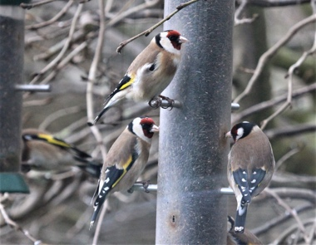We have recently cleared the hedge line on Jubilee Field. Many thanks to Ingrid Kibble for all her support. We are expecting the delivery of 420 hedgerow saplings that will provide all year round colour and encourage birds and other wildlife to the area. We would welcome volunteers when we are ready to plant out. Please watch the website for more information. You may also have noticed that the local farmers are leaving a border around most of the agricultural fields. These areas are being left and will have wildflowers seeded, hoping to attract wildlife and especially ground nesting birds. So, if you are out walking, please keep to the official footpaths and do not allow dogs to run through those margins.

**SWEFFLING WHITE HORSE BOWLS CLUB**We are hoping to open the green with our usual club competition for the George Holden Trophy on Easter Monday, 10th April.  
  
We are a small friendly club and will always welcome new members. We will be holding an open weekend when you can come along and try, or return to, flat green bowling. The green will therefore be open on the weekend of 15th and 16th April. You do not need any special equipment but we do ask that you wear flat shoes. Heels are not allowed on the green. If you are interested in giving it a go you can talk to our Secretary, John Stanley, on 01728 664073 or email him at [arthurjohnstanley@gmail.com](mailto:arthurjohnstanley@gmail.com)

**LENT SOUP LUNCH – WERE YOU THERE?**

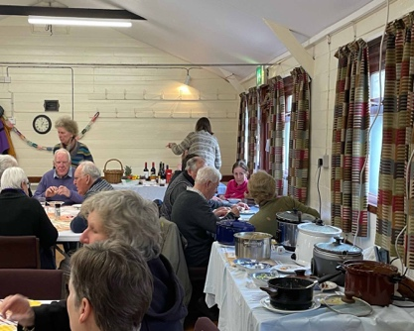 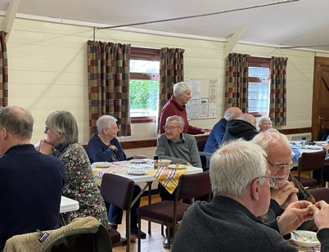 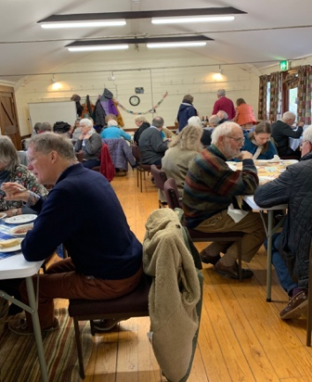

**NATURE NOTES**

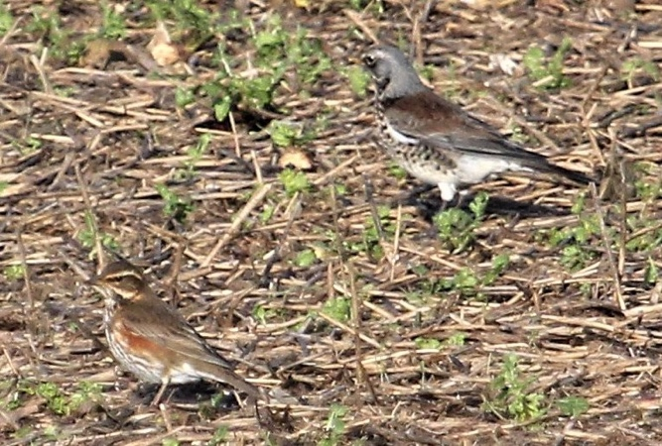It’s always satisfying when predictions turn out right. As I had hoped, by early March, the fields near the middle of the village, which had held turnips for the sheep, were full of winter thrushes. It was quite a sight, and I hope that many people (the paths here are popular for dog-walking) were able to see them. The birds were mostly Fieldfares – sometimes several hundred of them – more than I have ever seen anywhere before! With them were a smaller number of Redwings and even a few Mistle Thrushes, picked out by their rattling calls.

Mistle Thrushes are mostly not migrants; they are resident birds and breed in the village. Listen for their song, often remarkably early in the year, always delivered from very high in a tree. The song is something like a Blackbird, but simpler with just a few short phrases. It is very loud and carries a long way, a wonderfully evocative reminder in late winter that spring is on the way. The ‘rattling’ call resembles one of the old-fashioned wooden football rattles, (if anyone remembers them!). It is often given when the bird is flying away.

Our winter Garden Bird Watch went quite well, with most of the usual suspects turning up, like Blue Tits, Great Tits, House Sparrows and Dunnocks. The RSPB website on which we record it helpfully saves the results from past years, so it is easy to make comparisons. As usual, our commonest birds were Blue Tits, although I find them almost impossible to count as they carry seeds off to eat them out of sight. Some birds, like Blackbirds, were fewer than before, and Collared doves absent altogether, although I know they are still seen in most parts of the village. One surprise was Goldfinches, which we haven’t seen in the garden for the whole winter, but which turned up just in time for the count, feeding as always on the Niger seed. In past years we have seen a lot of them, up to twelve, sometimes in the company of Redpolls and Siskins (none of these this year).

I am always keen to promote flowers in the garden which appear early. They are important in providing pollen or nectar for the earliest emerging insects. A friend tells me that his earliest bumblebees have been using his 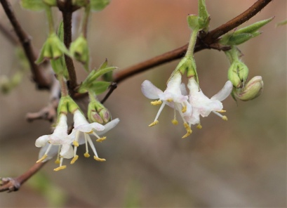There are a couple of species. Both have creamy or white flowers, flowering quite surprisingly from the middle of winter. They have short flower tubes (for a Honeysuckle) and abundant pollen – both ideal for the earliest bees, which mainly have short tongues. Winter Honeysuckles grow well in the village – several neighbouring gardens have them. They grow to a medium shrub, but they are almost indestructible and can be controlled as necessary. Plant one, ready for next winter. I prefer *Lonicera fragrantissima*, which has the bonus of a wonderful scent, but there is also *L. standishii*. Later Honeysuckles have longer flower tubes and are night scented, both features favouring pollination by moths.

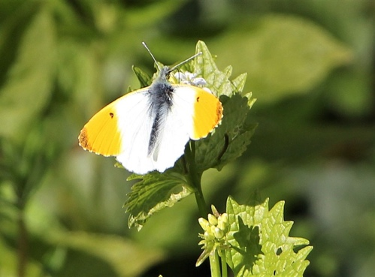A bi-monthly page on nature cannot do justice to all that there is to look out for at this time of year. Migrant birds are arriving, starting with the Chiff-chaff. The next wave of butterflies is emerging, notably Orange Tip and Holly Blue. There is a whole succession of wildflowers (I would pick out Primroses and, later, Cowslips in the lanes and verges). But the common ones are important. At an excellent talk on bees recently, I learned that the most important flower for sustaining the early-emerging bumblebees, which gardeners won’t want to hear, is the Dandelion! *Geoffrey Abbott*

**SWEFFLING HUT NEWS**

**HIRING SWEFFLING HUT - WITH WI-FI**

Anyone can hire the Hut for personal or public use, for example:

* Children's parties
* Work or study groups using The Hut's newly installed Wi-Fi.
* Celebrations with use of the small but well-equipped kitchen

60 seated for meals, 80 standing.

* Talks and film shows (licensed to show film and TV)

Current rates £7 an hour

Please ring Anne Gladwell (663710) for more information and to book

**HYGGE  AT THE HUT**

 Warm Up on Wednesdays continues at the Hut until Easter with 7 hours of free heating, food and drink, games and crafts every Wednesday 10am - 5pm.

Hygge at the Hut has been operating  since November using the ESDC grant 'Ease the Squeeze' and so we are very pleased that so far the team has served 285 free meals to 52 different adults with visits from even more adults accompanying a total of 12 children.

**You haven't come yet - WHY NOT?**

**Everyone is affected by the cost of living crisis -**

**SO DON'T MISS OUT!!!  EVERYTHING IS FREE!!**

The final ‘Hygge at the Hut’ will be 10am - 5pm on Wednesday 5th April.

As this will be in the Easter holidays, we are making it child-friendly with an afternoon showing of a film, 2pm start.  We can’t advertise which film this will be but it will be ‘U’ classified.  Please accompany children.  **NO CHARGE!!**

**WHO WOULD LIKE TO MEET REGULARLY IN THE HUT TO PAINT?**

Jenny Tyson is planning a regular painting workshop in The Hut, where anyone can bring their own work (any medium) for an informal session - 2/3 hours.

If you are interested, please contact Jenny with suggestions of days, times and format.

Tel: 663571 or  <[swefflinghut@gmail.com](mailto:swefflinghut@gmail.com)>

**CHAT AND CRAFT IN THE HUT**

First Mondays of every month at The Hut. 10.00 a.m. - lunchtime

Come to the Hut with any portable craft to chat and share time with others. 10am - 12noon

Refreshments available. All welcome.

**SWEFFLING HUT COMMITTEE MEETING**

The Biannual Hut Committee meeting will be held on Tuesday 16th May 7.30pm at the Hut. Minutes of the November 22 meeting and agenda will be posted on the Village website nearer the time.

All Sweffling Residents are welcome to attend.

**SWEFFLING LITTER PICK SATURDAY APRIL 1st**

Meet outside Sweffling Hut at 10.00 a.m. to collect all the necessary kit. The more people that take part the quicker it will be done! Help keep our beautiful village pristine. For further details contact Julia Kinsey on 664085.

**PLANNING FOR SWEFFLING FETE**

**Fete Date - Saturday 12th August. Time - 1pm - 4pm**

**Fete Place - Townlands Trust Meadow**

Everyone is invited to a Planning Meeting on

**Thursday May 11th 7.30pm. Wine & Nibbles to tempt you!**

**What will your household offer for an afternoon of Family Fun?**

* Run a stall or a game
* Food or Drink
* Help with the Dog Show
* Organise the Draw

**Ideas to <swefflingfete@gmail.com>**  **Thank you**. *Jill.*

**BYGONES MUSEUM OPEN DAY SUNDAY 14TH MAY 11 A.M. – 4.30 P.M.**

Vintage and classic cars Tractors

Stationary engines Motorbikes and auto cycles

Display of push bikes Household bygones

Traditional music players. The spinners and ruggers

Private exhibits and demonstrations

1900’s working kitchen in action

Horticultural and agriculturalbygones

**Lunches and refreshments**

**Admission free but collections for East Anglian Air Ambulance**

(All exhibits subject to availability)

**SWEFFING TENNIS CLUB** **WELCOMES NEW MEMBERS - OPEN TO ALL**

Last year SWEFFLING TENNIS CLUB had an excellent non-slip surface laid. It is now very much a professional standard court. We would very much like to encourage new members to join this family friendly club. We have a variety of subscriptions:  families, households, individuals, and juniors.

We will also be holding our annual BBQ on 2nd June from 4.30 pm. We have a tennis coach coming between 4.30 and 6.30 who will offer a free session to younger members, and any others who would be interested in joining the club. We are offering up to 14 months membership to anyone who would like to join the club before 1st June – our annual renewal date.

For all information contact Sue Rusack, Club secretary: [SueRyderR@rusack.myzen.co.uk](mailto:SueRyderR@rusack.myzen.co.uk). Please let me know if you would be interested in coming to the BBQ, as further details will be sent out in May. In addition, if you would like a trial practice game please get in touch.

**CHURCH SERVICES: April/May 2023**

|  |  |  |  |
| --- | --- | --- | --- |
| Date | Venue | Time | Service \***By extension** |
|  |  |  |  |
| HOLY WEEK | | | |
| April 2nd | Sweffling | 9.30 a.m. | Palm Sunday. Holy Communion |
| April 6th | Bruisyard | 7.30 p.m. | Maundy Thursday Holy communion |
| April 7th | Cransford | 10.00 a.m. | Walk of Witness and service (see page 2) |
| April 9th | Rendham | 9.30 a.m. | Easter Sunday Holy Communion by extension |
| April 9th | Sweffling | 11.00 a.m. | Easter Sunday Holy Communion by extension |
| April 16th | Sweffling | 9.30 a.m. | Morning Prayer |
| April 23rd | Rendham | 9.30 a.m. | Holy Communion |
| April 30th | Bruisyard | 10.00 a.m. | Benefice Service |
|  |  |  |  |
| May 7th | Sweffling | 9.30 a.m. | Holy Communion |
| May 14th | Rendham | 9.30 a.m. | Morning Prayer |
| May 21st | Sweffling | 9.30 a.m. | Morning Prayer |
| May 28th | Rendham | 9.30 a.m. | Holy Communion |
|  |  |  |  |
| June 4th | Sweffling | 9.30 a.m. | Holy Communion |

**JUBILEE FIELD: HELP REQUIRED!!**

420 saplings have been donated to the village by the Woodland Trust, together with protective spirals and bamboos canes for support. They have arrived are to be planted along the long boundary to the south side of the Jubilee field to provide shelter, a habitat for nature and all-year-round colour for the field boundary. If you can help with the planting, please contact the chairman of the Parish Council, John Stanley on [arthurjohnstanley@gmail.com](mailto:arthurjohnstanley@gmail.com)

**KING CHARLES III - CORONATION CELEBRATION**

Plans are under discussion for a village celebration for the coronation of King Charles III on the weekend of May 6th - 8th 2023. More information will be available shortly and will be circulated round the village and posted on the village web-site.

**PANCAKES & COFFEE SATURDAY MARCH 25th**

**SWEFFLING HUT 10.00 a.m. – 12.00 noon**

**IN AID OF THE BRITISH HEART FOUNDATION**

Never mind breakfast!! Come and enjoy a cup of freshly brewed coffee or tea and freshly made pancakes. Choose your own toppings. £4.00 per person

Eleanore Fitzgerald, in her role as International Junior Miss Suffolk 2022, is raising money for the BHF and is hosting this event.



A**CC SPRING FLOWER SHOW SATURDAY APRIL 1st SWEFFLING HUT**Exhibits to Hut 9-10am, Judging at 10am. Entry forms in Village Halls and on Village websites.  Show opens at 2pm. Entry £1 (includes tea/coffee). Under 12s free.  Presentation of cups at 3pm followed by Raffle.  Enquiries ring Lynda on 663325.

New exhibitors welcome, you don’t have to be an expert.



**PHOENIX SINGERS CONCERT**

Saturday April 1st, 7.00 p.m.Framlingham College

**JS BACH ST JOHN’S PASSION**

**Engage afresh with the Easter Story**

Tickets £15, under 18s free. Available from:

Hall farm Butchers, 25 Market Hill Framlingham

[william@glasse.org.uk](mailto:william@glasse.org.uk) Choir members and at the door

**‘FIVE IN A BAR’CONCERT IN SWEFFLING CHURCH SATURDAY APRIL 15th 7.00 p.m.**

Enjoy an evening of song performed by our local excellent a cappella group.

**­­­­­­­­­­­­­­**£8.00 adults, £4.00 children to include interval refreshments. Book with Sheila Tesh 01728 663518.

**VERY FORWARD DATES FOR YOUR DIARY:**

Harvest Thanksgiving and Harvest Lunch – October 1st

Christmas Brunch and Market – November 25h. Brass Band Concert – 8th December

Carols by Candlelight 17th December

­­­­­­­­­___________________________________________________________________

­**Please e-mail any news items, events or short literary items for consideration for inclusion in the June/July edition to john.tesh@talk21.com before May 12th.**

The editors welcome contributions for The Bridge but reserve the right to edit. Accuracy of the content is the responsibility of the submitter. We are limited to 8 pages and so may not be able to publish everything we receive. Dated items of village interest will be given priority. Please include your name and contact details in case we need to get in touch. **The Bridge is sponsored by**

**St. Mary’s Church and is delivered free to all houses in the Village.**