**The Rev. Martin Percival 01728 598455**

**e-mail: revmepercival@gmail.com**

**THE BRIDGE**

**Church and Village magazine for Sweffling**

**December/January 2022/2023**

**From the Rev. Martin Percival:**



Who is this man Jesus? Why is there a continuing fascination with him, even

when many people think that Christianity

is in decline? The basic facts of his life are

agreed my many historians.

This is not just mythology or Christian propaganda. We have more hard evidence about the life of Jesus than we have for

many people in the ancient world.

He was born in Bethlehem just over two thousand years ago. He grew up in a Jewish family in the village of Nazareth about

sixty miles north of Jerusalem.

He was a carpenter who then became a rabbi, a Jewish teacher. He impressed people

with his teaching and his ministry of healing, and gathered a group of followers around him in a community he called the Church.

He got into a long running confrontation with the religious authorities and was put to

death by Roman crucifixion in Jerusalem. His followers claim that he had risen from

the dead and had appeared to them, and that he was still present with them in some mysterious way.

What is equally striking is the way he touched people’s lives. His teaching made a

deep impression upon them. His kindness moved them. His stories amused them. His honesty shook them. His prayer had an intensity and a sincerity they had never seen

before. People wanted to be with him, even if at the same time he made them uncomfortable. There was an attraction that they could not explain. They began to

think: Perhaps he is the Messiah we have been waiting for? Maybe he is the Saviour

who will fulfil all the promises that God has made to the Jewish people?

This is the Christian faith: That Jesus is the Son of God, who comes from the Father.

That he is God himself, because he shares God’s very nature. It is clear in the Holy Scriptures that Jesus is much more than a prophet or a teacher. His followers came to worship him as they would the God of Israel. When we look at Jesus we look into the

face of God.

There is a peculiar phrase in the Bible, which we shall read in our Christmas lessons, which says that ‘God pitched his tent among us.’ He came into our world. He became

a human, in the womb of his mother, the Virgin Mary, and bridged the gap between heaven and earth.

This is the story of Christmas, when Jesus was born in a stable in Bethlehem. However, it doesn’t end there. To quote that wonderful couplet at the end of John Betjeman’s poem ‘Christmas’:

*‘That God was man in Palestine*

*And lives today in Bread and Wine.’ Martin*

**CHRISTMAS SERVICES IN St. MARY’S, SWEFFLING**

**CAROLS BY CANDLELIGHT**



[This Photo](https://pngimg.com/download/38646) by Unknown Author is licensed under [CC BY-NC](https://creativecommons.org/licenses/by-nc/3.0/)

**SUNDAY December 18th 6.00 p.m.**

**(Note later date, so you can watch the Football World Cup Final!)**

**A service of Lessons and Carols for Christmas**

**CHRISTMAS EVE MIDNIGHT HOLY COMMUNION**

**Service will begin at 11.30 p.m.**

**EPIPHANY CAROL SERVICE**

**SUNDAY January 15th 9.30 a.m.**

**NEW RECRUITS:**

**THE BENEFICE CHOIR** is looking to recruit new members to sing at the Carol service and on Christmas morning (if possible). If you would like to take part, please contact Sheila Tesh (663518) or Charles Seely (663467). Practises will begin at the end of November.

**BELL RINGING:** Why not try a new activity. Sweffling is looking for new ringers to join our team. Teaching given. For more information contact Suzanne Stevens (664074).

**VILLAGE NEWS**

**THANK YOU:**

Teresa Coleman is grateful for all the help and support, and the kind gifts and cards, she has received during Jorge, her border collie’s, illness. It made all the difference to her during a very difficult time. Jorge’s kind heart finally gave out on November 5th after a long battle with an injury. He will be missed by everyone who knew him.

**HARVEST IN SWEFFLING:**

The Harvest Thanksgiving service was very well attended and the congregation enjoyed singing the well-known harvest hymns and giving thanks for all God’s bountiful goodness. The church was beautifully decorated with flowers, foliage and berries and the gifts of packaged and tinned goods, toiletries etc. that had been so generously donated by the village were arranged around the church on windowsills, pews, the font, wherever there was space to put them. So much was donated that it completely filled the back of a large estate car, when it was packed up and taken to the Saxmundham Social Supermarket, who received the gifts with grateful thanks.

Fifty-four people attended the Harvest Lunch in the hut and enjoyed a delicious meal

of cottage pie with vegetables and harvest-themed puddings. Together with the proceeds

from the raffle a total of £600 was raised, which has been sent to TEAR Fund for the Pakistan flood relief fund.

**SWEFLING PARISH COUNCIL:**

The Parish Council meet in the Sweffling Village Hut on the second Tuesday of each month except August and December at 7.30pm. Our next meeting is scheduled for 10th January 2023, all are always welcome to attend. Next year is also due to be an election year. There will be an election on 4th May 2023. We have seven Councillors. Our

present Councillors are, Jill Abbott, Jude Chin, Amanda Daniel, Julia Kinsey, Audrey Lummis, John Stanley and John Tesh.  
  
We presently have a vacancy for the position of Clerk. If you might be interested in

this post please feel free to contact any of our Councillors. *John Stanley, Chairman*

**SWEFFLING WHITE HORSE BOWLS CLUB**:

The bowls green is next to the Village Hut in Sweffling.  
We recently held our AGM which was attended by the majority of our

members. We will once again have teams in both the Saxmundham League

and the Woodbridge and District Bowls League for the 2023 season. We also have

teams that compete for the Fynn Trophy and various Cup Competitions.  
  
We have members from Sweffling, Rendham, Bruisyard, Farnham, Saxmundham,

Melton and Leiston. We will always welcome more members. You do not need to be

an experienced bowler, we welcome complete beginners. The season runs from the end

of April through to early September. We will be having an Open Weekend in early

April when you can come along and try Bowls. Look out for more information closer

to the time.  
  
If you would like to find out more please contact our Secretary, John Stanley,

on 01728 664073 or at [arthurjohnstanley@gmail.com](mailto:arthurjohnstanley@gmail.com)

**MORE THANKYOUs: MACMILLAN COFFEE MORNING:**

Many thanks to all who supported the MacMillan coffee morning in any way, either helping, making cakes, or making a donation.  
We had a terrific result this year, the total raised was £1120.75.

**CHRISTMAS SHOPPING BUS TO NORWICH:**

Many thanks to Sweffling Townlands Trust and ALDE Community Council for each giving a donation towards the bus to Norwich.   The cost of the bus has doubled this

year, obviously due to fuel increases, and without a full bus the ticket price would be unacceptable.  The donations have enabled the trip to go ahead, and we are all very grateful.

Thank you one and all for your work throughout the year, I wish you all a Happy Christmas and a healthy New Year. *Lynda Newson*

**REMEMBRANCE SUNDAY**

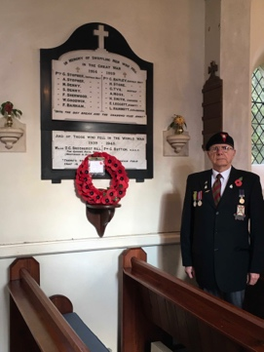On November 13th there was a joint Service of Remembrance for Sweffling and Rendham in Rendham Church, conducted by Professor John Tesh. The service began with the Two Minutes Silence, and then Richard Stevens beautifully played the Last Post on the tenor trombone. Poppy wreaths for both villages were blessed, laid on the War memorial by Dennis Moore and Jonathan Stevens and the names of the fallen from both villages were read by Lesley Bennion and John Tesh. The service continued with hymns, bible readings and poetry, read by Jo Rogers, Suzanne Stevens, Frances Hill and Anne Fitzgerald. John Tesh gave the address and prayers and the service concluded with the reveille played by Richard and the National Anthem. It was a very moving and thought-provoking service. After the service, the Sweffling wreath was brought back to the War Memorial in Sweffling Church, where it was laid by Kim, Hayes, short prayers were said, the names were read by Jill Abbott and the Kohima Epitaph and the Remembrance were read by Sheila Tesh.

**NATURE NOTES** **DECEMBER 22 – JANUARY 23**

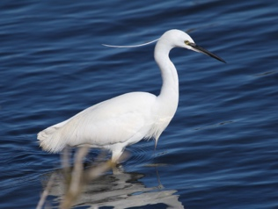When I first started birdwatching in Suffolk in the ‘60s, there were no Little Egrets here. Little Egret was not even given in my bird book as a British bird! Since then, they have spread up from the Mediterranean, through Europe, and they are now well established here as a breeding bird, especially common on our coastal marshes. Although not abundant in our valley, they are a regular feature. Look for a small heron, (long black bill, with long neck tucked up) and brilliant white - I think the whitest bird there is. They are seen flying up the river or feeding on the floodplain meadows. Usually there is a thin, wispy crest, and if you are especially keen, you might see that the toes, at the end of black legs, are yellow, an esoteric point but useful in distinguishing other species of egrets which are also on their way to colonising.

Walking with my brother alongside the river in October there was a small splash, which he saw was a Water Vole diving in from the bank. I was thrilled about this. At Flatford in the ‘60s Water Voles were common and we could watch and study them easily. Since then, they have suffered a huge decline in numbers and range – there are 95% fewer in Britain than there were then! Reasons given include deterioration of their waterside habitat and predation by the introduced American Mink. I knew that they are hanging on in the Alde Valley; I have found a few of their skulls in local Barn Owl pellets but have not actually seen one here. Bigger than our other voles, with thick, chocolate coloured fur, about the size of a rat but with a shorter tail and shorter, fur covered ears, they have often been called ‘Water Rats’. Ratty, in The Wind in the Willows, is a Water Vole, as you can see from Shepherd’s illustrations. More about them if they make a comeback here on the Alde.

During the late warm weather, we have been seeing a number of insects preparing for hibernation. Usually, we mention these in relation to the Autumn flowers of Ivy, which

are so important for them. This year a late crop of apples (Ashmead’s Kernel) has attracted feeding wasps, which will all die, except for a few large ones which are next year’s queens. There were even a couple of butterflies on the windfalls – Red Admirals, which I have seen before feeding on old fruit, but which are thought to survive the winter only rarely, and Commas which hibernate successfully, to be one of the first butterflies to emerge next spring. There have also been quite a number of large queen bumblebees, and in the back porch the biggest queen Hornet I have ever seen.

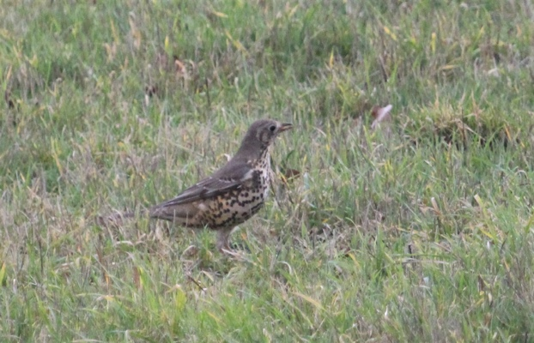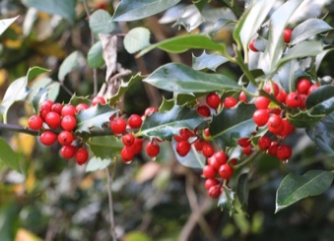Fieldfares have been here since mid-October, flying between woods and fields, and a few Redwings have already joined with the Blackbirds to completely strip the Holly berries in our garden. There are also a good number of Mistle Thrushes around, making their loud rattling call, but these seem to be in family sized groups rather than bigger flocks. They are as big as a Fieldfare, but much plainer grey. This year in Sweffling there are again fields of fodder beet for the sheep. Last year these fields were extremely attractive to all the thrushes at the end of the winter, so look out for them again in 2023. Also regarding berries, it struck me what a large crop of Blackberries there was this year. A few of these are eaten by Blackbirds, Wood Mice, Bank Voles and others, but most seem to go uneaten, and end up dry and shrivelled on the bushes. In fact some of these seeds do still get eaten during the winter, some by mice and voles which climb up to get them, and some by Bullfinches, which are adept at taking small seeds from the stalks. *Geoffrey Abbott*

**NEWS AND EVENTS**

**THE NEW VILLAGE WEBSITE!!!!** [**www.sweffling.onesuffolk.net**](http://www.sweffling.onesuffolk.net)

Keep up to date with all the village news and activities. Many thanks to Amanda Daniel and Lura Parsons-Mann for all their hard work in setting up the website.

There are areas on the website for all the organisations in the village.  However, it will only be useful if you send Laura reports of what has happened in the village, or what is planned. Contact her on: [laurap_02@hotmail.com](mailto:laurap_02@hotmail.com)

**WHAT’S GOING ON AT THE HUT?**

The new Hut Committee has been busy organising community events since reconvening

in July.  At the AGM on Tuesday 15th November, the current Standing Committee was returned and subcommittees were established for the different aspects of managing the Hut.  For all the details of this meeting go to <[www.sweffling.onesuffolk.net](http://www.sweffling.onesuffolk.net)> organisations-The Hut.

**CHAT AND CRAFT** will meet on Monday December 5th for coffee and friendly chat. For those who were there last time, an opportunity to make a collage of the printing that was done. **Bring prints and scissors.** Next meeting Jan. 9th 10.00 a.m. -12.00 noon, postponed from Jan. 2nd due to Bank Holiday. ALL WELCOME - bring your own craft!

**KEEPING WARM! HYGGE IN THE HUT**

Hygge is a Danish word meaning cosiness and comfortable friendliness.

The Hut is lovely and warm and we are opening it up every Wednesday, beginning on November 23rd, for anyone to come, to work, play, chat and lunch together.  We are hoping many will get involved in this community effort to beat the effects of Winter!

Thanks to the Parish Council, we are installing **Wi-Fi**which means you can come and do your work in the Hut.  **Open every Wednesday from 10am - 5pm, free drinks, and lunch for a small donation.**

Please get in touch if you can offer any help - rota for cooking (soups and stews), lifts for those who are house bound, comforting activities (board games, jigsaw puzzles) etc.

Contact <[swefflingfete@gmail.com](mailto:swefflingfete@gmail.com)> for more information or to request a lift.

**A MONTHLY SWAPSHOP.**

August was the month for swapping fruit and vegetables, later it was perennial plants.  November was Christmas decorations and Christmas jumpers.  In January it will be CDs, books and unwanted Christmas presents!

The Swapshop idea is that you can swap your unwanted item for free!  Receive a ticket to be exchanged for something you do want!  There is a period for browsing then all the swapping takes place at once at an arranged time.  Coffee and cake are always available for £2 a time.

**FIRST THURSDAYS AT SWEFFLING WHITE HORSE:**

Our next Community Supper is on Thursday 1st December at 7.30pm and will be a curry night.  Anyone who would like to come should email Jill Abbott on <[swefflingfete@gmail.com](mailto:swefflingfete@gmail.com)>.  Marie and Mark open the pub especially for us and as space is limited, the first 24 to respond will secure a place.   Those not cooking make a minimum donation of £6 and any profits go to The Gambia for medicines and bed nets to combat malaria. Future dates (provisional): January 5th, February 2nd, March 2nd. *Jill Abbott*

**SAVE THE DATE - FOR SWEFFLING FETE!**

**YES the Fete is ON - Saturday 12th August 2023**

**on the Townland Meadow and plans will be made in the Spring.**

This was the decision of the Sweffling Fete Organisation AGM on Thursday

20th October held in Sweffling Hut. The meeting appointed the standing committee: Chairman (Fete Co-Ordinator) Jill Abbott, Honorary Treasurer Mike Smithson and Minutes Secretary Sheila Tesh.  Grateful thanks were given to Amanda Daniel for her dedication over the years as treasurer and to Pam Fagan as Secretary.

Although Covid has prevented the village holding a full-blown Fete for the

last three years, SFO has organised two fund-raising events which together

have raised a fair sum to be shared by Sweffling Church and Village Amenities.  Thanks were recorded for Amanda who organised these very successful events: The Alde House Garden Party in 2021 and the Ceilidh in August of this year.

The sum of £1900 was duly divided; a retaining fund was set at £300; the Church receiving half of the remainder - £800, The Hut £400 and the Bowls Club £400.  It was decided that all stallholders would provide their own float as this would greatly help the treasurer and free up the need for a large float.

Jill Abbott, as fete co-ordinator indicated that she was looking for someone to shadow her role for 2023 as this would be her last year as chairman. *Jill Abbott*

**CHILDREN’S LANTERN -MAKING WORKSHOP**

**FOLLOWED BY CAROL-SINGING WITH SYZEWELL GAP**

**3.00 pm ON THURSDAY 22nd December at Sweffling Hut,**

***Lantern-making Workshop for 12 children followed by High Tea.***

***Carol Singing along the Street with Syzewell Gap accompanying.***

***Who will then play carols in Alde House Garden, (magically lit with Christmas lights). Mulled Wine (for the adults) and mince pies.***

**Tickets: Children £8 inclusive of workshop and tea - booking essential.**

**Adults £8 to include Music, mulled wine and mince pies.**

**To book** - put money through the egg shed cash box slit, making sure it is sealed in an envelope marked Lantern Workshop and the name of the child/children and a contact

email or phone number. The Alde House Garden carols will start at about 6.30pm

**CHURCH SERVICES: December/January 2022-2023**

|  |  |  |  |
| --- | --- | --- | --- |
| Date | Venue | Time | Service \***By extension** |
|  |  |  |  |
| December 4th | Sweffling | 9.30 a.m. | Holy Communion |
| December 11th | Rendham | 9.30 a.m. | Morning Prayer |
| **December 18th** | **Sweffling** | **6.00 p.m.** | **Carols by Candlelight** (No morning service) |
| **December 24th** | **Sweffling** | **11.30 p.m.** | **CHRISTMAS EVE**  **Midnight Holy Communion\*** |
| **December 25th** | **Rendham** | **9.30 a.m.** | **CHRISTMAS DAY Holy Communion\*** |
|  |  |  |  |
| January 1st | Sweffling | 9.30 a.m. | Holy Communion |
| January 8th | Rendham | 9.30 a.m. | Morning Prayer |
| January 15th | Sweffling | 9.30 a.m. | **EPIPHANY CAROL SERVICE** |
| January 22nd | Rendham | 9.30 a.m. | Holy Communion |
| January 29th | Badingham | 10.00 a.m. | Benefice Holy Communion |
|  |  |  |  |
| February 5th | Sweffling | 9.30 a.m. | Holy Communion |

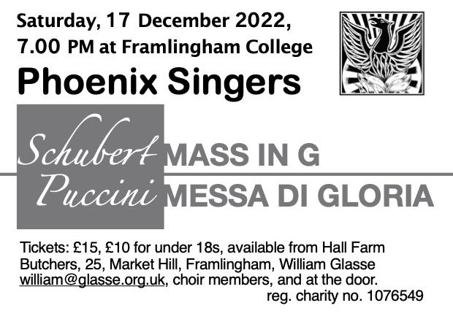

**RENDHAM MUMMERS** celebrate the Winter Solstice, on the year’s shortest day, December 21st. on the Knoll, Rendham at 7.30 pm. Collection in aid of IP17 Food Bank.

**CHRISTMAS BRUNCH AND MARKET, SWEFFLING HUT**

**SATURDAY DECEMBER 3rd 10.00 A.M. – 12 NOON**



[This Photo](https://www.flickr.com/photos/jonno101/3420421853) by Unknown Author is licensed under [CC BY-NC-ND](https://creativecommons.org/licenses/by-nc-nd/3.0/)

Bacon and egg rolls, Freshly brewed coffee/tea

Christmas themed stalls: Cakes, Craft, Presents, Preserves, Pickles, Door Wreaths and Table Decorations, Raffle

Proceeds in aid of St. Mary’s Church

**“CHRISTMAS BRASS” CONCERT in SWEFFLING CHURCH**

**FRIDAY DECEMBER 9TH, 7.30 P.M.**

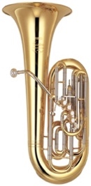

[This Photo](https://en.wikipedia.org/wiki/Tuba) by Unknown Author is licensed under [CC BY-SA](https://creativecommons.org/licenses/by-sa/3.0/)

Leiston Royal British Legion Brass Band will play a concert

of popular and Christmas music, with Sing-along Christmas

Carols. **The perfect start to Christmas in Sweffling!**

Tickets: Adults £8.00, Children £4.00 to include interval

refreshments

Book with Diana (663578) or Sheila (663578) or pay at door.

Proceeds in aid of St Mary’s Church

**PAINTING WORKSHOPS IN THE HUT:**

In January, February and March 2023 Gabriel Lange, with a lifetime of teaching experience after training at Emerson College, Sussex, Rudolf Steinerseminariet in Sweden and the Assenza Painting School in Switzerland, is coming to Sweffling Hut in 2023 to teach a series of 3 workshops, each two sessions, a fortnight apart.  The emphasis is on experiencing colours and how they relate to each other.  This is a meditative approach which can give new insights to experienced painters and be a good starting point for beginners as it deepens our relationship to colour through a sequence of colour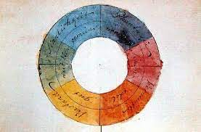 studies.  The medium is watercolour, using the technique of veil painting.  Amanda Daniel says that she finds inspiration, joy and peace doing this colour work and hopes that others will take the opportunity to share this experience with Gabriel in the New Year.  Places are restricted to 8 adults. Materials provided. For more information please ring Amanda at 663341 and save the dates 16th and 30th January Goethe’s Colour Circle, February 13th and 27th Dreiklang (Threefold Resonance) and March 13th and 27th subject to be decided later, each from 10 a.m. to 1.00 p.m.

**TREES FOR JUBILEE FIELD have been ordered for delivery March 2023. The Parish Council are looking for volunteers to help with planting. More next Bridge**

**____________________________________________________________  
Please e-mail any news items, events or short literary items for consideration for inclusion in the December/January edition to john.tesh@talk21.com before November 15th.** The editors welcome contributions for The Bridge but reserve the right to edit. Accuracy of the content is the responsibility of the submitter. We are limited to 8 pages and so may not be able to publish everything we receive. Dated items of village interest will be given priority. Please include your name and contact details in case we need to get in touch.

**The Bridge is sponsored by St. Mary’s Church and is delivered free to all houses in the Village.**