**The Rev. Martin Percival 01728 598455**

**e-mail: revmepercival@gmail.com**

**THE BRIDGE**

**Church and Village magazine for Sweffling**

**February/March 2023**



Signs of Spring are appearing in Sweffling, despite the very cold weather we

have experienced recently. As you walk around the village look out for snowdrops,

early crocuses daffodils already in bud and if you turn to Geoffrey’s nature notes you will see that the hazel catkins are already out. We are very fortunate to live in such a beautiful place! Whilst we enjoy our village, let’s not forget those areas of the world that are suffering from war, deprivation, famine and persecution and give thanks for our good fortune.

**From The Rev. Martin Percival:**

In the film *Unbreakable*, Bruce Willis gets on to a train and sits down on a seat by

the window. Shortly afterwards a woman comes into the carriage and sits near him. She

is young and beautiful, and she catches his eye. The camera focuses on his hands and

we see him turning his wedding ring, pulling it off his finger, and hiding it in his pocket.

Without any words being said, we are aware of what is about to happen. The ring is a

symbol of his marriage. He knows it and he knows that others know it, which is why

he wants to conceal it.

Symbols are important. They help us to see what someone believes and what they care

about.

Every Sunday morning, when we meet together for worship, we say the Creed in one

form or another. It is an important moment in the service. A creed is a written summary

of what Christians believe. In the early centuries many Christians died defending the

Christian teaching.

It’s the whole amazing adventure of faith, from before creation until the end of time,

squeezed into just a few lines, with the death and Resurrection of Jesus Christ at the

very centre. In itself, the creed is quite short, but it’s like a crystal that reflects the light

of a million suns.

There are different versions of the creed. The Nicene Creed, which we say together at the Eucharist, is incredibly old and goes back to the fourth century. One of the versions of it still in existence was written by hand in Egypt about one thousand and five hundred years ago. The Apostles’ Creed, which is said at Matins and Evensong, is even older, and goes back nearly two thousand years to the Christian community in the second century AD. Both sum up the teaching of Jesus and that of the whole Bible in just a few words. They give us a direct connection with the faith of the early church.

Therefore, let us ask ourselves the question. What do we believe? What do we care about? What motivates us? It’s not just a religious question. Everyone has their own convictions and values, even if they do not use the words ‘faith’ and ‘belief. For Christians, the creeds are absolutely central. They are a symbol, a summary of what we believe. They become a sign of our commitment to that faith over the course of time. *Martin*

**REPORT OF CHRISTMAS EVENTS IN SWEFFLING:**

**Christmas Brunch and Market:**



[This Photo](https://pngimg.com/download/38646) by Unknown Author is licensed under [CC BY-NC](https://creativecommons.org/licenses/by-nc/3.0/)

On December 3rd, in the Village Hall, delicious bacon (and egg) rolls and freshly brewed tea and coffee were enjoyed by everyone who came to shop at the varied Christmas themed stalls. It was a time to catch up with friends and chat. A total of £432.40 was raised for church funds. Thanks to everyone who helped and those who supported this event.

**DATE FOR 2023: SATURDAY NOVEMBER 25th 10-12 noon**

**Christmas Brass Concert:**

After a two-year absence, due to Covid, the 15th Annual Brass Band concert was held in Sweffling Church on December 9th. The theme was “Christmas Memories” and the audience enjoyed an eclectic programme of Popular Christmas music and carols, expertly played by the Leiston Royal British Legion Brass Band. Delicious mince pies and tea/coffee were enjoyed in the interval and there was a Christmas Raffle.. Many thanks to the Band, who turned out in force despite the freezing weather, to the mince-pie makers, to those who donated raffle prizes, to the local business who advertised in the programme and to the many who supported the concert. Proceeds will be donated to St. Mary’s Church.

**BOOK THE DATE FOR 2023: FRIDAY DECEMBER 8th at 7.30 p.m.**

**Carols by Candlelight:**

Despite the Football World Cup Final there was a large congregation for the service of Nine Lessons and Carols. The Church was beautifully decorated and the large Christmas tree looked splendid. Many thanks to all those who helped in any way. The Benefice Choir led the singing of the well-known carols and also sang three choir items. Thank you to Charles Seely and the choir members for adding to our worship. The Christmas story was unfolded through the nine lessons – thank you to all the readers and to John Tesh for stepping in at the last minute to lead the serviceas the Rev. Percival was unwell. Mince pies, tea/ and coffee were served after the service, so thanks again to the cooks.

**NEXT YEAR’S CAROL SERVICE: DECEMBER 17th at 5.00 p.m.**

**Christmas Eve Midnight Benefice Holy Communion:**

Possibly due to each of the other churches in the Benefice having a service on Christmas Day Morning, the congregation at the midnight service of Holy Communion by extension was small. Nevertheless, it was a time of quiet reflection on the real meaning of Christams before the bustle of Christmas day. Thank you to John Tesh for presiding at this service.

**WRITE THE SERVICE IN YOUR DIARY FOR NEXT CHRISTMAS EVE**

**Epiphany Carol Service:**

The Epiphany Carol Service, led by John Tesh, was held on Sunday January 15th and followed the same pattern as the Nine Lessons and Carols. The readings foretold the coming of the Magi to Bethlehem, the presentation of their gifts to the Christchild, the flight of the Holy Family into Egypt, their return to Nazareth.and the revelation of Christ not only to Jews but also to Gentiles. The Epiphany hymns and Christmas carols were chosen to complement the readings. It was a fitting end to Christmas worship in the village.

**CHRISTMAS TREE ON THE TRIANGLE:**

If you drove through the village over Christmas, you will have noticed the Christmas tree on the grass triangle at the fork of the Benhall-Glemham road. It really brightened up this entrance to the village. Very many thanks to Jason Gaythorne-Hardy for donating the tree and to Ray and Bea Whittleton for erecting the tree, providing the lights and switching them on each evening. Hopefully this might become part of the Sweffling Christmas scene each year!

**SWEFLING PARISH COUNCIL NEWS:**

2023 will be an election year for both the District and Parish Councils.  
The Village Hut, as our local polling station, should be open on Thursday 4th May. The process for these elections will begin in March.  
The Parish Council has seven members and all positions will be up for election. Nomination papers will be available from the middle of March. If seven, or fewer, nominations are lodged by early April then those nominated will be elected unopposed. If there are more than seven nominations then polling will take place alongside the District Council elections. I would encourage everyone eligible to vote to make sure you are registered or to apply for a postal vote if you wish.  
The unusual thing about this election in May is that all voters will be required for the first time in Great Britain to show photographic identification (photo ID) at the polling station before they are given a ballot paper. More information can be found at [eastsuffolk.gov.uk](http://eastsuffolk.gov.uk) and will be available from the Parish Council when the process begins

in March.  
  
Unfortunately the Parish Council is presently without a Clerk. It would be nice to have one in place before these forthcoming elections. Please see the advertisement below that has been posted with Suffolk Association of Local Councils (SALC).  
  
“**There is a vacancy for a Parish Clerk to work from home, attend evening meetings and act as the Responsible Financial Officer (RFO) for this small Parish Council. The salary will be on the NALC pay scales and set according to experience.**”  
  
Swefling Parish Council are seeking to appoint an experienced Clerk. However, an unqualified person will be considered as training would be provided through SALC.  
We generally meet on the second Tuesday of each month, except for August and December. The Clerk will be required to attend these ten meetings, generate agendas, take minutes, keep the Council accounts and implement Council decisions. A good knowledge of both WORD and EXCEL would be essential. The Clerk is required to advise Councillors on all legal and procedural matters connected with the work of a small Parish Council.  
  
To apply, or seek further information, please contact our Chairman John Stanley by email at [arthurjohnstanley@gmail.com](mailto:arthurjohnstanley@gmail.com)

**LANTERN WORKSHOP IN THE HUT:**

Two days before Christmas Eve, 12 excited children attended a lantern making workshop at the Hut.  This was followed by supper, then Carol-singing around the village accompanied by the folk group Syzewell Gap.  Even though it was raining, the lanterns shone brightly and the children sang for an hour and a half with support from accompanying adults.  Thanks to Amanda Daniel for hosting very welcome refreshments for the adults after a rather damp evening.  Syzewell Gap were brilliant, with their accompanying in very difficult conditions, playing their instruments through plastic bags!

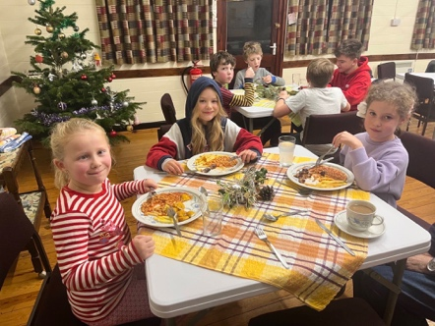 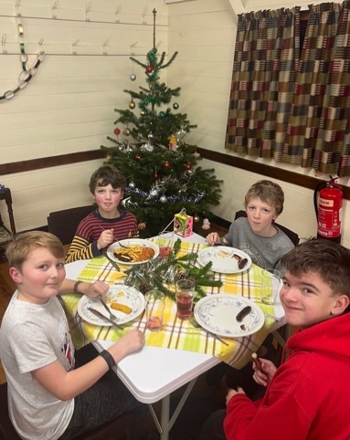

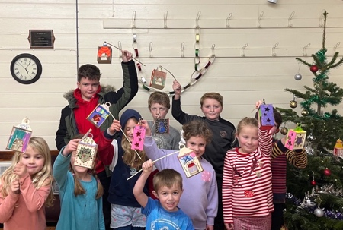 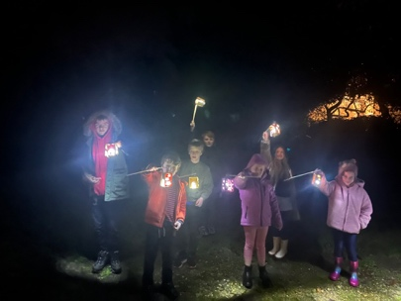

**NATURE NOTES February – March 2023:**

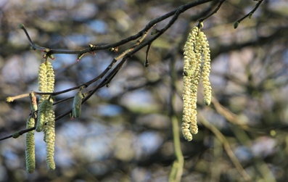Apart from one icy week, our winter this year has been extremely mild. Everyone will have observations of unusual phenomena, such as early garden flowers. I have sometimes referred to the catkins of Hazel as a welcome reminder of approaching spring, and Hazel is a common shrub in hedges throughout the Village. This winter, there were catkins fully out even by Christmas. Other wind pollinated trees have conspicuous male catkins, which produce the pollen. I expect that Birch and Alder catkins separate male trees) although from small cones rather than catkins. The one behind the Church produces clouds of pollen if you tap it on a dry day in late winter.

Winter moths on the wing are another feature of the season. Flying individuals are all males – the females have reduced wings and are flightless. In December there were nights when hundreds of these moths were flying around the hedgerows, picked up in car headlights. It seems strange that so many moths should be around at a difficult time of year, when in summer there are far fewer moths and other insects than there used to be.

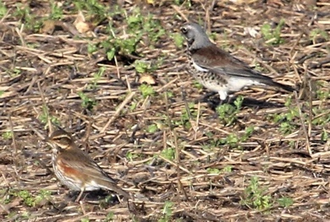Two large fields in the centre of the village have again been planted with turnips (fodder beet) as food for the sheep. Last year, after the sheep had finished at the end of the winter, there were large numbers of Fieldfares and other thrushes on these fields. They were very easy to see here. Fieldfares are again common around the Village this year. Look out for them (as well as Redwings) on the turnip fields later in the winter.

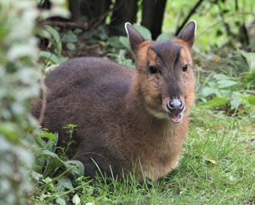We are still regularly seeing Muntjac Deer in the fields around us as well as in the garden. Although it is exciting to have wild deer around, they are not entirely welcome! In the wild they are very general feeders – much of their diet is made up of tough plants such as Bramble shoots – but in the garden they seem to be much more selective. At present they have cleared off all the Geranium leaves, and they are just waiting for the Tulips to show! In the middle of January a neighbour’s dog chased a muntjac down the drive and into our garden. I found it later in the afternoon sheltering in a corner outside the kitchen. It was a small individual, quite relaxed, with its ears back. It was chewing the cud - you can see its fat little cheeks. Muntjac are ruminants, so of course they chew the cud, but I don’t think I have noticed this before.

The Big Garden Bird Count is at the end of January. We are already noticing some differences from last year. There seem to be more Bluetits, but fewer finches and no Goldfinches at all. I will report next time. *Geoffrey Abbott*

**SWEFFLING WHITE HORSE:**

For those of you who don't know, we've started doing food. As you know, the Sweffling pub is mostly a drinking pub - and has been highly acclaimed as such but if (like me) you enjoy a nutritious but inexpensive home-cooked meal you are in for a treat.When the pub is open, we will be serving home-cooked delicious hearty meals, alongside our popular cheese toasties. They will be available every session (Fri-Mon), while stocks last.

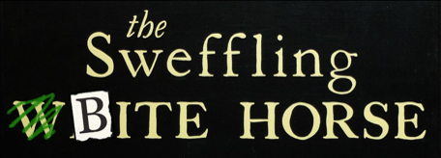  
The Sweffling B I T E Horse means a steaming pot of something home-made & cooked on our wood-fired range. Just one option, but something different each week - served with a chunk of bread. No side salad, no frills, no fries & definitely no knives and forks on the tables! All for just £6 a bowl. So far we have had Roasted Pumpkin Risotto, Punjabi Vegetable Curry, Roasted Vegetable Rogan Josh, Vegetable Chilli, Dhal & Roasted Vegetable Tagine. Come and join us! *Marie*

**HUT NEWS:**

**‘Hygge at the Hut’ has proved popular for young and old, workers and those retired, folk wanting company and a chat or some amusement.  We don’t have a word for feeling warm and comfortable inside with good company, but Hygge is a danish word meaning just that, so we have borrowed it!**

We are grateful to the Townlands Trust and East Suffolk District Council for their ‘Ease the Squeeze’ grants.  This has enabled the Hut Committee to organise the weekly Hygge warm hub where anyone can come to warm up, have free hot drinks and hot food.  Donations are very welcome but not expected!  The grants pay for the heating, equipment and weekly food bills and will do so until the end of March when we hope the weather will be warmer.

Numbers vary but at the Hygge the week before Christmas we had 35!  We had a special decoration morning at the Hut which entertained the children newly on holiday.  This was followed by a festive meal, carols and a quiz.

Grateful thanks go to all who are generously giving of their time to maintain this welcome warm hub in the Village Hut every Wednesday.  If anyone would like to join the expanding team of helpers please email: The Hut address  <[swefflinghut@gmail.com](mailto:swefflinghut@gmail.com)>

**New to the Hut - now licensed to show films!**

And will start to do so at the Hygge on selected Wednesday afternoons.

If there is enough interest, we may also have a second showing Wednesday evenings which will be a fundraising event.

**Advertising for Events, Classes, talks and workshops**

In line with laws on data protection the Hut Committee is moving towards using a Mailchimp to send you messages about events.  If you receive such an email please give your permission for these to go ahead.  It will be a safe and efficient way of letting you know what events are available.  Adverts will also appear on local social media websites such as ‘Beautiful Sweffling’ (the Closed Facebook group), Nextdoor, and the WhatsApp group ‘The Sweffling Grapevine.’  A paper flyer through the door will act as a visual reminder.

**Spring Planning**

The committee is currently planning spring events:

**Wednesday March 8th 7pm for 7.30pm: ‘PEOPLE, PHOTOS & PIZZA’ - an evening of stories behind the photos from 6 local photographers (each of whom will show just 6 photos).**

Details to follow and tickets will be available through Eventbrite on the village website.

Some taster sessions, workshops, courses or classes will soon be offered after a number of folk requested particular subjects.  These include: Making Silver Clay Jewellery; Repair sewing; Antiques and Collectables; Painting and Drawing; Village History; Photography; Nature; WW1 and The Hut.  Evening classes in particular and events for children.

Please continue to let us know what interests you.

**If you wish to book to hire the Hut yourself please ring Anne Gladwell 663710.  To book events there will be a link on the village website or you can email the Hut address <**[**swefflinghut@gmail.com**](mailto:swefflinghut@gmail.com)**>**

**CHAT & CRAFT AT THE HUT - NUNO FELTING**

**Monday 6th February 10 am sharp - 1pm**

Liz Eaton will lead a workshop on Felting and she will bring materials for each to make a scarf.  The cost per person will be £10 payable on the day (in addition to the usual donation for refreshments etc). Please book a week prior to the event, then a list of things to bring will be sent to participants.  <[swefflinghut@gmail.com](mailto:swefflinghut@gmail.com)>

**FIRST THURSDAYS AT SWEFFLING WHITE HORSE:**

Thursday February 2nd at 7.30pm is the community supper at Sweffling White Horse by kind invitation of Mark and Marie. The theme is pies and volunteers to cook are welcome.  Cost for those not cooking is £6 a head.

The March theme is yet to be arranged.  The date is Thursday 2nd March at 7.30pm.   Please email Jill at <[swefflingfete@gmail.com](mailto:swefflingfete@gmail.com)> if you would like to come.  Numbers are limited but new faces always welcome.

**CHURCH SERVICES: FEBRUARY/MARCH 2023**

Lent begins with Ash Wednesday on February 22nd. There will be a Benefice service of Holy Communion with Imposition of Ashes in Sweffling Church at 7.30 p.m.

|  |  |  |  |
| --- | --- | --- | --- |
| Date | Venue | Time | Service \***By extension** |
|  |  |  |  |
| February 5h | Sweffling | 9.30 a.m. | Holy Communion |
| February 12th | Rendham | 9.30 a.m. | Morning Prayer |
| February 19th | Sweffling | 9.30 a.m. | Morning Prayer |
| February 22nd | Sweffling | 7.30 p.m, | ASH WEDNESDAY Benefice service of Holy Communion with Imposition of Ashes |
| February 26th | Rendham | 9.30 a.m. | Holy Communion |
|  |  |  |  |
| March 5th | Sweffling | 9.30 a.m. | Holy Communion |
| March 12th | Rendham | 9.30 a.m. | Morning Prayer |
| March 19th | Sweffling | 9.30 a.m. | Morning Prayer |
| March 26th | Rendham | 9.30 a.m. | Holy Communion |
|  |  |  |  |
| April 2nd | Sweffling | 9.30 a.m. | PALM SUNDAY Holy Communion |

**LENT COURSE:**

Martin is organising a Lent Course for the Benefice to be held in Sweffling Church at

7.00 p.m. on Monday evenings in Lent, commencing on March 8th. Each session will be approx. one hour and everyone is invited to attend, you will be very welcome.

**WATER QUALITY TESTING ON THE UPPER ALDE:**

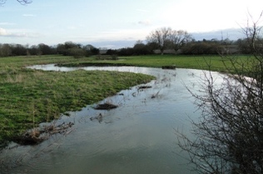**Robert Rusack writes:** I am organizing a team of volunteers to take regular samples of water from different parts of the upper Alde The samples are tested for Nitrates and E-Coli.

The team is part of a scheme run through the Alde and Ore Assoc. If you feel that you would be able to spend 90 minutes on a monthly basis being involved with this survey please contact me at [Robert@rusack.myzen.co.uk](mailto:Robert@rusack.myzen.co.uk)

**JUBILEE FIELD: HELP REQUIRED!!**

420 saplings are being donated to the village by the Woodland Trust, together with protective spirals and bamboos canes for support, and will be delivered at a date between March 6th and March 17th, 2023 (date to be confirmed). They are to be planted along the long boundary to the south side of the Jubilee field to provide shelter, a habitat for nature and all-year-round colour for the field boundary. If you can help with the clearing and planting, please contact the chairman of the Parish Council, John Stanley on [arthurjohnstanley@gmail.com](mailto:arthurjohnstanley@gmail.com)

**UPCOMING EVENTS:**



[This Photo](https://theskinnyfork.com/blog/roasted-bell-tomato-soup) by Unknown Author is licensed under [CC BY-NC](https://creativecommons.org/licenses/by-nc/3.0/)

**LENT SOUP LUNCH: SATURDAY MARCH 4th**

**SWEFFLING HUT 12.00 noon – 2.00p.m.**

The Annual Lent Soup Lunch, in aid of the hospital we support in the Gambia, As much home-made soup and bread as you can eat.

Adults £6.00, children £3.00

If you can help by making soup or donating a raffle prize, please contact Sheila Tesh (663618) or Jill Abbott (663402).

All proceeds to the Gambia.

**PANCAKES & COFFEE SATURDAY MARCH 25th**

**SWEFFLING HUT** **10.00 a.m. – 12.00 noon**

**IN AID OF THE BRITISH HEART FOUNDATION**

Never mind breakfast !! Come and enjoy a cup of freshly brewed coffee or tea and freshly made pancakes. Choose your own toppings. £4.00 per person

Eleanore Fitzgerald, in her role as Miss Suffolk 2022, is raising money for the BHF and willbe hosting this event

A**CC SPRING FLOWER SHOW** **SATURDAY APRIL 1st SWEFFLING HUT**Exhibits to Hut 9-10am, Judging at 10am. Entry forms in Village Halls and on Village websites.  Show opens at 2pm. Entry £1 (includes tea/coffee). Under 12s free.  Presentation of cups at 3pm followed by Raffle.  Enquiries ring Lynda on 663325.

New exhibitors welcome, you don’t have to be an expert.

**‘FIVE IN A BAR’CONCERT IN SWEFFLING CHURCH SATURDAY APRIL 15th 7.00 p.m.**

Enjoy an evening of song performed by our local excellent A Cappella group

**­­­­­­­­­­­­­­**£8.00 adults, £4.00 children to include interval refreshments. Book with Sheila Tesh 01728 663518.

­­­­­­­­­___________________________________________________________________

­**Please e-mail any news items, events or short literary items for consideration for inclusion in the April/May edition to john.tesh@talk21.com before March 15th.**

The editors welcome contributions for The Bridge but reserve the right to edit. Accuracy of the content is the responsibility of the submitter. We are limited to 8 pages and so may not be able to publish everything we receive. Dated items of village interest will be given priority. Please include your name and contact details in case we need to get in touch. **The Bridge is sponsored by**

**St. Mary’s Church and is delivered free to all houses in the Village.**